Cells

Move cells
You can move cells in Excel by drag and dropping or using the Cut and Paste commands.
Move cells by drag and dropping
- Select the cells or range of cells that you want to move or copy.
- Point to the border of the selection.
- When the pointer becomes a move pointer , drag the cell or range of cells to another location.
Move cells by using Cut and Paste
- Select a cell or a cell range.
- Select Home > Cut or press Ctrl + X.
- Select a cell where you want to move the data.
- Select Home > Paste or press Ctrl + V.

Copy cells
Copy cells in your worksheet using the Copy and Paste commands.
Copy cells
- Choose a cell to copy.
- Select Copy or press Ctrl + C.
Paste cells
- Choose a cell to paste.
- Select Paste or press Ctrl + V.

Combine data
You can combine data from multiple cells into a single cell using the Ampersand symbol (&) or the CONCAT function.
Combine data with the Ampersand symbol (&)
- Select the cell where you want to put the combined data.
- Type = and then select the first cell you want to combine.
- Next, type & and use quotation marks with a space enclosed.
- Select the next cell you want to combine and then press enter. An example formula might be =A2&" "&B2.
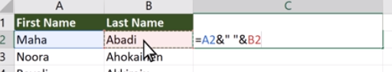
Note: To combine the text from more than two cells, continue selecting cells, and typing &” “& after each cell you select. If you don’t want to add a space between the combined text, type & instead of &” “&. To add a comma, type &”, “& (a comma followed by a space, both enclosed in quotation marks).
Combine data using the CONCAT function
- Select the cell where you want to put the combined data.
- Type =CONCAT (.
- Select the cell you want to combine first.
Use commas to separate the cells you are combining and use quotation marks to add spaces, commas, or other text.
- Close the formula with a parenthesis and press Enter. An example formula might be =CONCAT (A2, " Family").
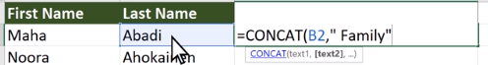

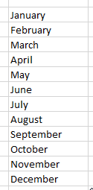
Auto Fill dates
With the Auto Fill feature, you can automatically fill cells with data that follow a pattern or series.
- Select a cell and type the first word of a series (e.g. type "January" for a 12-month series).
- Select the fill handle at the lower-right corner of the cell, hold down, and drag to fill the rest of the series. Fill handles can be dragged up, down, or across a spreadsheet.
Note: If you only enter a three-letter abbreviation (e.g. "Jan") in the cell, Auto Fill will automatically fill in the rest of the series.

Validate cell data
When you create worksheets that will be used by others, it’s important to make sure they can only enter valid data. Use Excel’s data validation features to make rules to restrict the type of data or values that others can enter into a cell.
- Select the cell(s) you want to create a rule for.
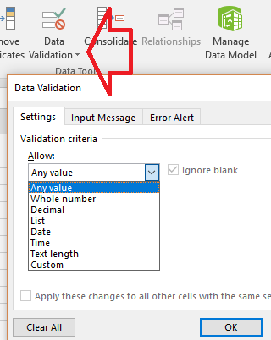
- Select Data >Data Validation.
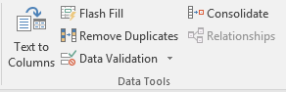
- On the Settings tab, under Allow, select an option:
  - Whole Number - to restrict the column to accept only whole numbers.
  - Decimal - to accept decimal numbers.
  - List - to pick data from the drop-down list.
  - Date - to restrict the cell to accept only date.
  - Time - to restrict the cell to accept only time.
  - Text Length - to restrict the length of the text.
  - Custom – for custom formula.

- Under Data, select a condition:
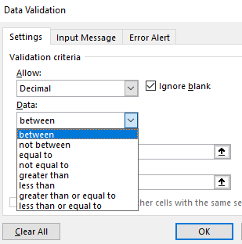
  - between
  - not between
  - equal to
  - not equal to
  - greater than
  - less than
  - greater than or equal to
  - less than or equal to

- On the Settings tab, under Allow, select an option:
- Set the other required values, based on what you chose for Allow and Data.
For example, if you select between, then select the Minimum: and Maximum: values for the cell(s).
- Select the Ignore blank checkbox if you want to ignore blank spaces.
- If you want to add a Title and message for your rule, select the Input Message tab, and then type a title and input message.
- Select the Show input message when cell is selected checkbox to display the message when the user selects or hovers over the selected cell(s).
- Select OK.
Now, if the user tries to enter a value that is not valid, a pop-up appears with the message, “This value doesn’t match the data validation restrictions for this cell.”

Create a custom number format
Create and build a custom numeric format to show your numbers as percentages, currency, dates, and more.
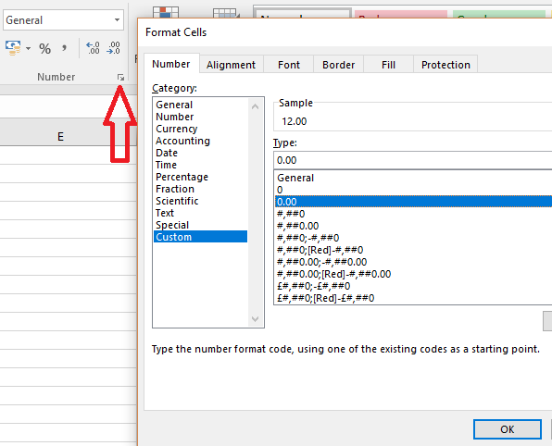
- If there's data you'd like to apply a custom format to, select it.
- Select More in the Number group.
- Select Custom.
- In the Type list, select an existing format, or type a new one in the box.
- To add text to your number format:
  - Type what you want in quotation marks.
  - Add a space to separate the number and text.
- Select OK.

